Case Study 7
Profile of M/s VPP
Name of Enterprise | M/S VPP
Directors | 1. Sri G, Director  2.Sri N, Director
Constitution | Private Limited
Factory Address | Nalgonda
Established | 2014
Line of activity | Manufacturing plastic egg trays which are used by wholesale egg dealers.
SSI Registration No.
GST

- Line of Activity:
Entrepreneur engaged in Manufacturing of plastic egg trays which are used by wholesale egg dealers.
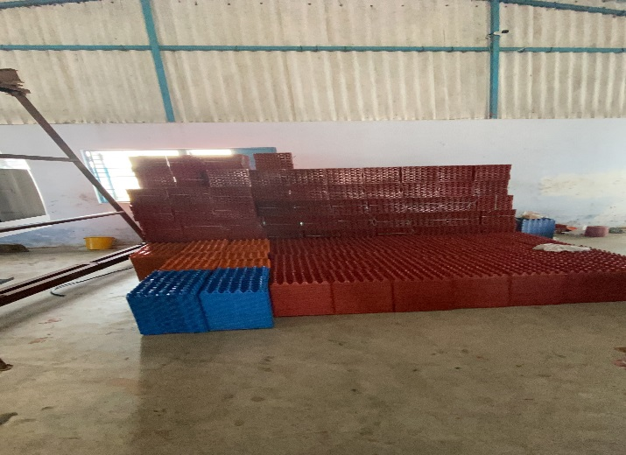

- Managerial Competencies:

Sri G –
He has relevant experience of over 30 years in plastic industry. Before starting this business in 2016, he worked as Manager & In charge of finance and sales in Uma Swastik Plast Pvt Ltd and Universal Plastics which manufactures egg trays and other plastic goods. He is actively involved in this business and looking after all the financials and operations of the unit.

- Machinery:
The unit is operating with two machineries of egg trays, one cooler and one grinding machinery. The unit manufactures plastic egg trays. Raw material used is plastic granules acquired from waste plastic products from various regions like UP, Maharashtra, Karnataka etc at the rate of ₹65 per kg. The production capacity at 100% is 6000 trays per day working 24hrs shift. Pre-Covid, the unit was running at 70% capacity producing 4500 trays per day. The price of each tray is ₹19. Monthly 30 tons of material are required for smooth production. The cash generation cycle is 30 days. The wastage from the production is used for recycling and will be grinded into chips/granules. There is CCTV installation in the unit and maintained well. There is enough water supply.
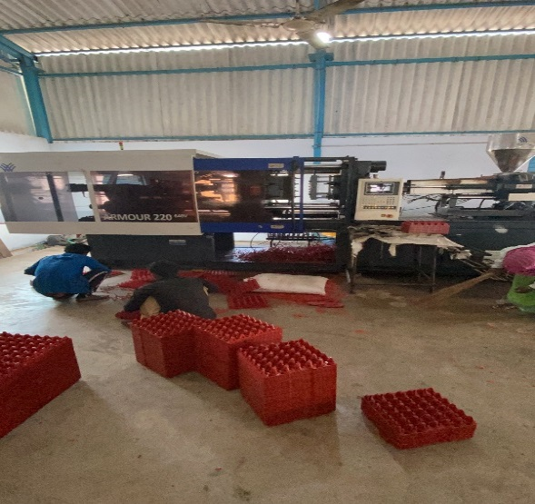
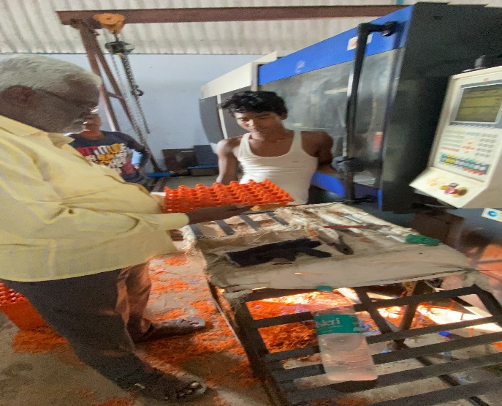
* M/S VSP
- Manufacturing Process:
Plastic granules are dumped into heating & pressing machines. The plastic granules melt due to the set temperature and then the molds are fixed to the machine which will mold the melted plastic into the required shapes and then instantly cooled to make it a finished product. Here the molds used are egg tray molds.

- Marketing:
- There are continuous orders for seamless production
- Enterprise has good potential in domestic market not only in Telangana State but also in other states of the country like UP, Maharashtra, Karnataka.
- They also supply to local Egg dealers in and around Hyderabad.

- TIHCL intervention:
The enterprise was operating under stress from December 2018 due to change in trade practice in procurement of the raw material. Generally, the suppliers used to give the credit of almost 45 to 60 days in the past. But due to changed market conditions like reduction in credit cycles, those units are not providing credit instead insisted for immediate payment. Due to this change in the practice, the company had to shell down in advance the amount for purchase of the raw material and dragged the unit into stress and resulted in NPA. The customer initially approached us for bridge finance on sanctioned incentives which is likely to take longer time.

TIHCL has diagnosed the enterprise and identified following reasons of sickness
- The customer used to procure the raw material on credit 60-90 days. However due to the changed market conditions the customer had to procure the material in advance. Then prevailing cycle of creditor has decreased from 90days to almost zero.
- As the enterprise has a long-standing relationship with customers, enterprise couldn’t put pressure on them to make early payments.
- Due to advance payment to the suppliers the customer could not rotate the receivables due to the credit period. Due to this the company has faced low production capacity for 5 months because of low procurement of raw material.
- High Debt burden of Term Loan EMIs and higher interest rate.
- Receivables delayed in last 6 months due to cash crunch in the market and by other govt policies
As per TIHCL resolution package, TIHCL has Sanctioned Critical Amount Funding (CAF) of ₹1.8 million and account has become regular in the books of primary lender (SFC). A moratorium of 6 months was provided.

Key indicators | Pre-Revival | Post TIHCL intervention
No of EMIs pending with primary lender | 3 | 0
Capacity Utilization | 60% | 75%
Turnover | Rs 3.2 million | Rs 8.5 million
Employment | 14 | 18

- Labour Status: (post TIHCL intervention)
Gender | Skilled | Unskilled
Men | 4 | 11
Women | 0 | 3
Total | 4 | 14

Livelihood: At 75% capacity they have employed 18 workers and their families are dependent on this enterprise which is around 30 individuals including entrepreneurs. In full capacity there will be need of another 2-3 workers.

